**Contact Information:**

Please contact Pam at:

Office: 920.832.2428

Fax: 920.739.6707

E-mail: pschneider@wipfli.com

**Pamela W. Schneider**

Partner, Director of Estate Planning

**Current Position and Responsibilities**

Pam Schneider is a Partner at Wipfli LLP and Director of the Estate Planning Group. She gives tax and transactional planning advice to business owners, executives and high net worth individuals, with a focus on tax planning including estate and charitable planning, succession planning, and retirement and financial planning. Pam incorporates her broad tax and legal background in the advice she gives.

**Specializations**

* Individual income, gift, estate and charitable tax compliance and planning
* Retirement and financial planning
* Business and Executive succession planning

**Past Experience**

* Attorney with Schiff Law Firm in Chicago, Illinois
* Attorney with Meltzer Purtill & Stelle Law Firm in Schaumburg, Illinois
* Paralegal with JPMorgan/Chase in Chicago, Illinois
* Paralegal with Coughlin & Coughlin, S.C. in Appleton, Wisconsin

**Awards**

* Becker CPA Scholarship award recipient

**Professional Memberships and Activities**

* Community Real Estate and Personal Property Foundation, Inc. of the Community Foundation for the Fox Valley Region – Board Member
* Fox Valley Estate Planning Council – Member
* Greater Green Bay Community Foundation – Past Board Member and   
  Executive Committee - Secretary
* St. Norbert College - Development Committee - Member
* BellinHealth Foundation - Development Committee – Past Committee Member
* Green Bay Estate Planning Forum – Past President & Board Member
* U.S. Tax Court - Member
* American Institute of Certified Public Accountants (AICPA) – Member & Conference Presenter
* Wisconsin Institute of Certified Public Accountants (WICPA) - Member
* American Bar Association (ABA) - Member
* Institute of Management Accountants (IMA) – Past Board Member
* National Business Institute (NBI) - Member

**Education**

Kent College of Law - Chicago, Illinois

* Doctorate Masters in Taxation (LL.M) - Graduated cum laude
* Juris Doctorate of Law (JD) - Graduated cum laude

University of Wisconsin-Oshkosh

* Bachelor of Business Administration degree in Accounting - Graduated cum laude

Lakeshore Technical College - Cleveland, Wisconsin

* Paralegal associate’s degree - Graduated with high honors

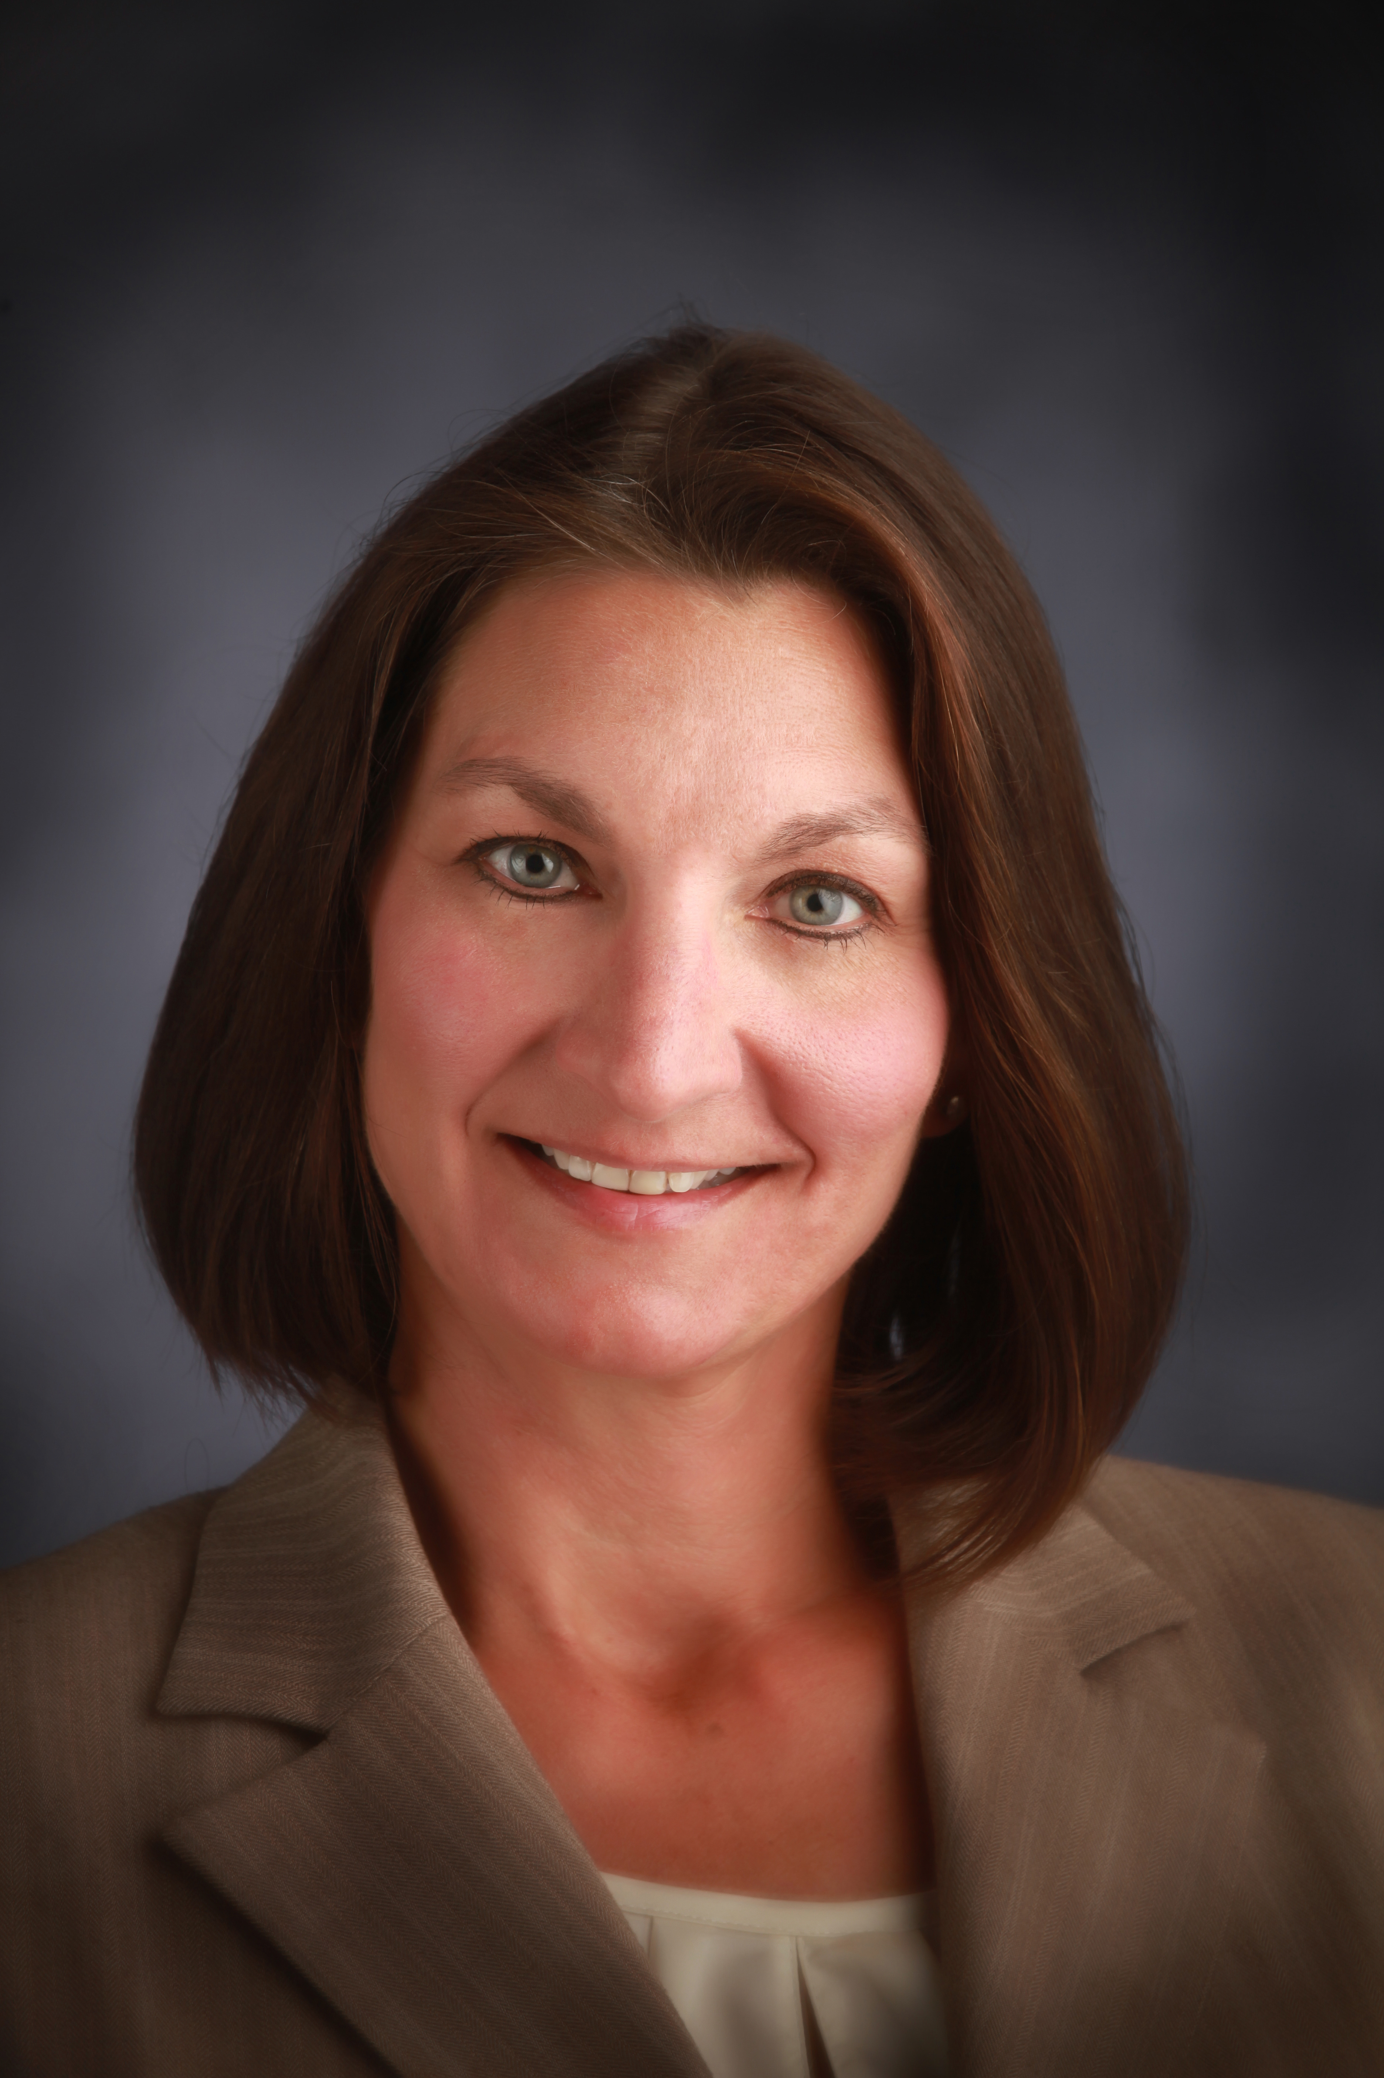

**Certifications:**

Certified Public Accountant

Certified Management Accountant